./



Title: Requirements for Automatic Water Level Controlling System

Version Number: 01

Name: Vanka Vinaya Kumar

PS No: 99007917

Module: Model Based System Engineering

**Requirements for Automatic Water Level Controlling System (A.W.L.C.S)**

**-by Vanka Vinay Kumar**

**Table Of Contents**

**1. Requirements.………………………………………………………...………...4**

**1.1 Introduction……………………………………………………………...4**

**1.2 Features………………………………………………………………….4**

**1.3 SWOT Analysis………………………………………………………….5**

**1.4 5W's and 1H……………………………………………………………..6**

**1.5 High-Level Requirements………………………………………………7**

**1.6 Low-Level Requirements……………………………………………….7**

**2. Architecture……………………………………………………………………….8**

**2.1 Block Level Diagram Representation………………………………….8**

**2.2 Flow Chart Representation………………………………………..…..10**

**2.3 Circuit Level Diagram Representation………………………….…….11**

**2.3 Components Required……...………………………………………….11**

**3. Implementation……………………………………………….………………….13**

**3.1 Process of Implementation……………………………………………...3**

**4. Test Plan and Output…………………………………………………………….3**

**4.1 High Level Test Plan……...……………………………………………..3**

**4.2 Low Level Test Plan…………….……………………………...………..3**

**4.3 Output Representation…………………………………………………..3**

**5. Images and Videos……………………………………………………………….3**

**5.1 Working video…………………………………………………...………..3**

**5.2 Images.….………………………………………………………..……….3**

**6. Simulation…………………………………………………………………...……..3**

**6.1 Working Simulation...……………………………………………………..3**

**7. Report……………………………………………………………………………….3**

**7.1 all contents…………………………………………………...…………….3**

**Document History**

|  |  |  |  |  |  |
| --- | --- | --- | --- | --- | --- |
| **Ver.Rel. No.** | **Release Date** | **Prepared. By** | **Reviewed By** | **Approved By** | **Remarks/Revision Details** |
| 01 | 24/02/2022 | Vinay Vanka |  |  |  |
|  |  |  |  |  |  |
|  |  |  |  |  |  |
|  |  |  |  |  |  |
|  |  |  |  |  |  |

1. **Requirements**
   1. **Introduction**

Nowadays everyone is looking for automation and advancements in all sectors. The Automatic Water Filling System is capable to start and stop the water pump to fill the overhead water tank according to the water level in that tank. Usually, we turn the water pump "on" to fill the tank and forgot to turn it "off" at that moment water overflows from that tank which leads to a lot of wastage of water and electricity. In this project, the sensor will sense the level of water in the tank, based on that the controller will set the water pump to turn "on" and "off" when required. The Heater will generate the heat and an LCD will show requested the temperature. In our project we have used an ATmega328 microcontroller along with a temperature sensor, Pushbutton, Heat generator, LED and LCD, etc.

* 1. **Features**

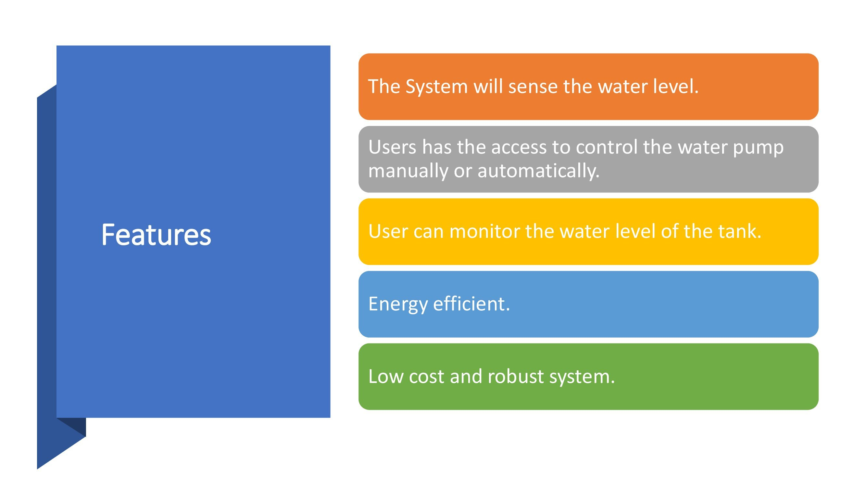

* 1. **SWOT Analysis**

* 1. 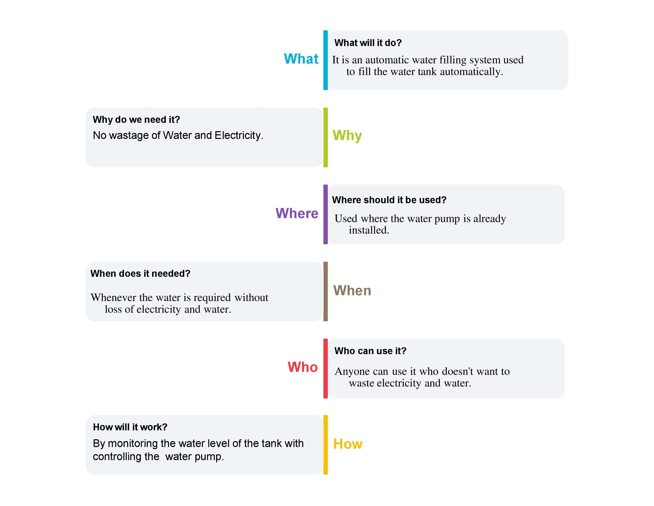**5W's and 1H**
  2. **High-Level Requirements**

|  |  |
| --- | --- |
| **HLR ID** | **High Level Requirement** |
| HLR1 | It should sense the water level from the tank |
| HLR2 | It should turn the pump ON/OFF according to the water level in the tank |
| HLR3 | It should have manual controls to turn the pump ON/OFF |
| HLR4 | It should display the water level of the tank |

* 1. **Low-Level Requirements**

|  |  |  |  |
| --- | --- | --- | --- |
| **LLR ID** | **Low Level Requirement for HLR1** | **LLR ID** | **Low Level Requirement for HLR2** |
| **LLR1.1** | **It should have floating switch.** | **LLR2.1** | **It should have relay to control the pump.** |
| **LLR1.2** | **It should have capacitive sensor.** | **LLR2.2** | **It should have low water level.** |

|  |  |  |  |
| --- | --- | --- | --- |
| **LLR ID** | **Low Level Requirement for HLR3** | **LLR ID** | **Low Level Requirement for HLR4** |
| LLR3.1 | It should have manual ON/OFF button. | LLR4.1 | It should have display to show the water level in the tank. |
| LLR3.2 | It should have manual/automatic mode switch. | LLR4.2 | It should have LEDs for ON/ OFF indication. |

1. **Architecture**
   1. **Block Level Diagram Representation**

LCD Display

* This will display the water level in the tank and alerts like low water level indication, a tank full, etc.

Power

* Electric power supply to the microcontroller and Relay to drive the sensor and water pump.

Microcontroller

* It is the heart of the system where it controls the sensors to fetch water level, display the status and to control the water pump.

Water Pump (Actuator)

* To pump water from the ground and fill the water in the tank.

Water level sensor

* This will sense the water level in the tank and send it to the microcontroller.

LED Indication

* This will indicate that the water pump is turned on or off.

Manual ON-OFF Switch

* Manual switch will allow the user to control the water pump from the user end.

Automatic/manual control switch

* This is a single toggle switch that toggles between automatic and manual mode.
  1. **Diagram

     Description automatically generatedFlow Chart Representation**
  2. **Circuit Level Diagram Representation**

* 1. **Components Required:**
* AT mega 328 IC
* Float Switch (Sensor)
* Relay
* Power source ( 220v Ac & 5V Dc )
* Push button
* Toggle switches
* 16 x 2 LCD
* LEDs
* Diodes
* Registers
* Potentiometer
* Water Pump (Actuator)

1. **Implementation**
   1. **Process of Implementation**

**{program}**

|  |  |  |  |  |
| --- | --- | --- | --- | --- |
| **Test ID** | **Description** | **Input** | **Output** | **Status** |
| TID_01 | Manual Mode |  |  | PASS |
| TID_02 | |  | | --- | | Manual OFF pump | |  |  | PASS |
| TID_03 | |  | | --- | | Pump OFF indication | |  |  | PASS |
| TID_04 |  |  |  | PASS |
| TID_05 |  |  |  | PASS |
| TID_06 |  |  |  | PASS |
| TID_07 |  |  |  | PASS |
| TID_08 |  |  |  | PASS |
| TID_09 |  |  |  | PASS |
| TID_10 |  |  |  | PASS |
| TID_11 |  |  |  | PASS |
| TID_12 |  |  |  | PASS |
| TID_13 |  |  |  | PASS |
| TID_14 |  |  |  | PASS |